

Product Requirement Document
Social Commerce Platform

April 17, 2026

Prince Tiwari
Mayur Thakre

Resources and Team Roles:
For rapid development, a small cross-functional team is ideal. Possible roles:
- Product Owner/PM: Oversees scope, writes user stories/acceptance criteria, liaises with mentors or judges. Ensures alignment to the problem statement.
- Backend Developer(s): Builds APIs, integrates database, sets up authentication and payments. Implements real-time chat (WebSockets).
- Frontend Developer(s): Designs mobile UI/UX (using Flutter/React Native). Implements feed, live video UI, product pages.
- Full-Stack/DevOps: Deploys cloud infrastructure (app hosting, database, streaming service), sets up CI/CD pipeline, manages deployments.
- Designer/UX: Crafts wireframes, refines user flows, ensures accessibility and visual coherence. Creates mockups for pitch.
- Quality/Tester: Writes and runs test cases, verifies functionality and performance. (In hackathon, this may be a shared responsibility.)

Problem Statement :
Executive Summary: This PRD outlines a hackathon MVP for a social commerce platform aimed at empowering local sellers and engaging nearby buyers. It addresses the problem that traditional ecommerce often lacks personalization and local reach. In this platform, sellers can host live selling sessions (with real-time chat, reactions, Q&A) and share content (posts, short videos), while buyers discover products through an interactive social feed and direct messaging. By blending social interaction with ecommerce (a rising trend called social commerce ), the platform will enhance trust and visibility for small businesses.

Background & Context: Social commerce—integrating social interaction and content with shopping—is rapidly growing. In 2022, shoppers spent $992 billion on purchases through social media globally, a figure projected to reach $8.5 trillion by 2030 . Live-stream shopping, where users buy in real time during broadcasts, is especially popular in markets like China, India, and Thailand (over 70% of users have participated in live shopping ).

User Personas :
Priya (Local Seller): A 35-year-old boutique owner in a small city. Limited tech skills; relies on physical stores and word-of-mouth. Needs an easy way to showcase products live, reach new customers, and build trust. Hopes to increase sales without complex setups.

Ravi (Local Buyer): A 28-year-old professional who enjoys unique local goods. Active on social media and smartphone-savvy. Prefers interactive shopping (seeing demos, asking questions). Wants authentic reviews and recommendations from his community, and an easy way to shop conveniently from home.

Admin/Moderator: Platform manager overseeing quality. Ensures content is appropriate, monitors transactions, and maintains system health. Wants analytics on user engagement and sales trends.

Goals and Success Metrics (OKRs = Objectives and Key. KPIs = Key Performance Indicators)

Objectives:
Empower local commerce: Onboard 50+ local sellers in the first quarter; enable them to reach abroad audience through live events.
Engage community: Achieve high user activity (e.g., 1,000 active buyers within two months) and strong social interaction (e.g., average 50 chat messages per live session).
Drive transactions: Facilitate smooth purchases during and after live sessions to increase local sales volume.
Measure impact: Improve key e-commerce KPIs (conversion rate, retention, customer lifetime value, average order value) relative to baseline.
Key Metrics (KPIs): Based on industry standards, we will track engagement (session duration, messages sent), conversion rate (purchases made per visit), retention rate (percentage of repeat users), and growth in sales volume (Gross Merchandise Value). We will also monitor Average Order Value, sales conversion rate, traffic, customer lifetime value, and retention rate, as these are core ecommerce KPIs . Specifically for live commerce, we’ll measure live viewership count, engagement rate (comments/likes per viewer), and live-to-sale conversion (percentage of viewers who buy).

Features:

MVP Features (Priority & User Stories):
Feature | Priority | Effort | Impact | User Story (role, action, benefit) | Acceptance Criteria (concise)
Live Selling Stream | High | Medium | High | As a seller, I can host a live video session showing products, so buyers can see demos and purchase in real-time. | Seller can start/end a stream; viewers join; product tags appear; viewers can chat and buy during stream.
Interactive Chat | High | Medium | High | As a buyer, I can send messages and reactions during live streams, so I can ask questions and engage with the seller. | Chat messages and emojis appear instantly for all participants; seller can reply in chat.
Social Feed (Posts) | Medium | Medium | Medium | As a user, I can browse a feed of posts and short videos from sellers, so I discover new products and deals. | Feed displays latest posts and live event previews; posts can be liked/commented; images/videos render correctly.
Product Listing & Checkout | High | Medium | High | As a buyer, I can view product details and make purchases seamlessly, so I can buy items easily both during and outside live streams. | Buyers can view product page (images, price, description) and complete checkout via integrated payment gateway.
Profile & Ratings | Medium | Low | Medium | As any user, I can see seller profiles and product reviews, so I feel trust in transactions. | User profiles show seller info; buyers can rate products/sellers after purchase; average ratings displayed.
Direct Messaging | Low | Low | Medium | As a buyer, I can send a private message to a seller, so I can ask questions at my convenience. | Buyers can initiate 1:1 chat with seller; message history visible to both parties.

Post-MVP Features(Ye Baad mai dalenge)
- Enhanced Social Content: Support ephemeral “stories,” polls, and group/community pages to deepen engagement.
- AI Recommendations: Suggest products and sellers based on user interests and behavior (leveraging open-source ML tools).
- Influencer Collaboration: Allow tagging or integrating local influencers; track affiliate link conversions.
- Gamification: Badges, loyalty points, or discounts for frequent shoppers or top promoters.
- Analytics Dashboard (Admin): Provide real-time analytics on sales, user growth, and content performance for platform admins and for sellers (optional).
- AR/Virtual Try-On: For certain product categories (fashion, accessories), integrate AR previews.
Features are prioritized by impact on core goals. We will focus on high-priority MVP features first. The table above ranks each by priority, effort, and impact.

UX and Interaction Flows
The user journey will be intuitive and mobile-first. Below is a user flow diagram (mermaid syntax) illustrating a buyer discovering and purchasing a product via a live session:

FlowChart


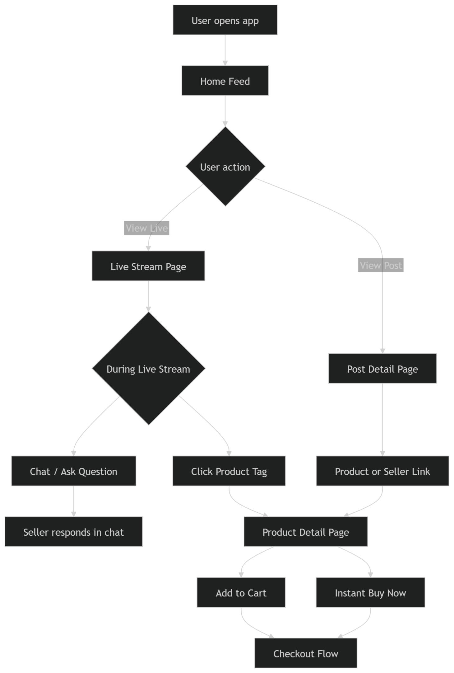

- Home Feed: The main screen shows a scrollable feed of seller content and live stream thumbnails. Each live thumbnail displays viewer count and a product highlight.
- Live Stream Page: When a user taps a live event, a full-screen video player appears with a side panel for chat and product tags. The user can type questions or react (like emojis). Clicking a tagged product pauses video and opens the product page.
- Product Detail Page: Shows images, description, price, seller info, and purchase options. From here, the buyer can Buy Now via quick checkout or add to cart.
- Checkout Flow: Seamless in-app payment (mobile card entry or integrated wallet). Confirmation and digital receipt provided.
- Seller Portal: Sellers log in to a “Go Live” dashboard, select which products to tag, write a stream title, and start broadcasting. They see live chat in real-time and a list of in-stream purchases.
Sample Screen Mockups (descriptions):
- Main Feed: Imagine a TikTok/Instagram-style feed with mixed content: posts (product photos or short videos) and embedded live-stream cards. Each live card shows a play icon, thumbnail, and viewer count.
- Live Stream: Video takes most of the screen; a semi-transparent chat overlay or side panel scrolls with messages. Product icons at bottom right float (shoppable overlays).
- Product Page: Clean layout with large image carousel, title, price, “Buy” button, and “Ask Seller” chat icon. Tabs below for description, reviews, and seller profile.
- Seller Dashboard: Simple UI with “Start Live Session” button, list of your listed products (each with a checkbox to tag in stream), and analytics (viewers count, sales made).

Data Model and API Surface
We define the core data entities and their relationships. The main entities include User, Product, LiveSession, Post, Order, Message, and Comment/Review. Below is an ER diagram (using mermaid syntax):
erDiagram
USER ||--o{ POST : creates
USER ||--o{ PRODUCT : owns
USER ||--o{ ORDER : places
USER ||--o{ LIVESESSION: hosts
PRODUCT ||--o{ ORDER : contains
PRODUCT ||--o{ LIVESESSION: featured_in
LIVESESSION ||--o{ MESSAGE : has
USER ||--o{ MESSAGE : sends
USER ||--o{ REVIEW : writes
PRODUCT ||--o{ REVIEW : receives
- USER: (id, name, email, passwordHash, role (buyer/seller), profile details)
- PRODUCT: (id, name, description, price, images, sellerId → USER.id, stock, status)
- LIVESESSION: (id, sellerId → USER.id, title, startTime, endTime, etc.)
- POST: (id, userId → USER.id, content, media, timestamp)
- ORDER: (id, buyerId → USER.id, productId → PRODUCT.id, quantity, totalPrice, status, timestamp)
- MESSAGE: (id, sessionId → LIVESESSION.id, userId → USER.id, content, timestamp)
- REVIEW: (id, productId → PRODUCT.id, userId → USER.id, rating, comment, timestamp)
The API surface includes endpoints like:
- Auth & User APIs: /register, /login, /users/{id} (GET profile), /users/{id}/followers, etc.
- Product APIs: GET /products, GET /products/{id}, POST /products, PUT /products/{id}, DELETE /products/{id}. Also search/query by category or keyword.
- Post APIs: GET /feed (paginated feed of posts and live sessions), POST /posts, GET /posts/{id}, POST /posts/{id}/comment.
- Live Session APIs: POST /live/start (initiate stream), POST /live/{id}/message (send chat message), GET /live/{id}/messages (fetch recent chat), GET /live/active (list ongoing streams).
- Order APIs: POST /orders (checkout), GET /orders/{id}.
- Review APIs: POST /products/{id}/reviews, GET /products/{id}/reviews.
- Admin APIs: (not required for MVP but possible) e.g. GET /analytics/engagement, content moderation endpoints.
All APIs use JSON over HTTPS, with JWT or session tokens for auth. Real-time features (chat, live updates) will use WebSockets or similar protocols for low latency.

Technical Architecture and Stack Recommendations
We propose a modern, scalable architecture:
- Mobile App (Buyer/Seller clients): A cross-platform mobile app using Flutter or React Native for rapid UI development. These frameworks can easily integrate video players and real-time chat widgets, and work offline-friendly if needed.
- Backend: A RESTful API server built in a familiar framework (Node.js/Express or Python Django). For real-time communication, we will use a WebSocket service (e.g. Socket.IO on Node.js) to handle live chat and notifications.
- Live Video Streaming: For live-selling video, we recommend using a managed streaming service like Amazon Interactive Video Service (IVS). IVS provides “easy low-latency live video streaming at scale”[8], which greatly simplifies implementation. Sellers can stream to IVS, and viewers watch with minimal delay. Alternatively, an open-source media server (e.g. Kurento or Ant Media) could be used, but managed services speed up development.
- Database: A relational database (e.g. PostgreSQL or MySQL) for core data (users, products, orders) ensures transactional consistency. We might also use Redis as a cache and message broker for chat. Media (images, video clips) and user-uploaded content will be stored in a scalable object store like AWS S3 or Google Cloud Storage.
- Authentication & Security: Use industry-standard OAuth 2.0/JWT for login sessions. All communication uses HTTPS. For payments, integrate a secure gateway like Stripe or PayPal (external APIs) to handle credit card processing; this offloads PCI compliance. Data encryption at rest and in transit is required by design.
- Cloud Infrastructure: A cloud environment (AWS/GCP/Azure) with auto-scaling for components. For example, AWS Lambda or Fargate for APIs, AWS RDS for database, AWS CloudFront CDN for static content, AWS IVS for streaming, and AWS Elasticsearch or Algolia for search. This stack leverages open-source frameworks but relies on managed services for rapid MVP delivery.
- Tech Stack:
- Mobile: Flutter or React Native, along with state management (Redux, Provider, etc.).
- Backend: Node.js or Python (Django/Flask) for APIs; Socket.IO or Django Channels for real-time chat.
- Video: AWS IVS / WebRTC.
- Database: PostgreSQL + Redis.
- Payment: Stripe API (no need to reinvent checkout flow).
- Monitoring: Use tools like Grafana/Prometheus or cloud monitoring for uptime and performance.
This tech stack is pragmatic for a hackathon: Flutter/React Native has many plugins, Node.js is popular for APIs and real-time apps, and managed cloud services reduce dev overhead. Critically, WebRTC is optimized for video streaming and WebSockets for chat[9][10], so we may use a combination (IVS handles video, while WebSocket handles chat/Q&A). This satisfies criteria for technical execution and architecture (reliable, scalable)[11].

Data and API Model Diagram
The data model diagram (above) visually captures entities and relationships. APIs correspond closely to these models: e.g. the /live endpoints interact with the LIVESESSION and MESSAGE tables, /products with the PRODUCT table, etc. This ensures consistency between the data layer and API layer. For example, when a buyer checks out, an ORDER record (linking USER to PRODUCT) is created, and inventory is decremented. Ensuring normalized data and clear foreign keys will help maintain integrity (especially for order transactions).

Non-Functional Requirements
- Performance: The platform must support real-time streaming and chat with minimal latency (<1-2 seconds end-to-end). Using CDNs and managed streaming (like AWS IVS) helps. Backend APIs should have response times under 200ms for interactive feel. We will load-test the system to handle surge scenarios (e.g., hundreds of concurrent live viewers). For example, automated scripts will simulate multiple users joining a live stream and sending messages, to ensure the WebSocket server scales (using horizontal scaling if needed).
- Scalability: Design as microservices or modular services so components can scale independently. For hackathon scope (small user base), a monolithic deployment might suffice initially, but we will containerize services (Docker) and use Kubernetes/ECS for future growth. Caching popular product queries in Redis can reduce DB load during peak. The architecture allows scaling video distribution via CDN and autoscaling the backend behind a load balancer.
- Security: All data in transit must use TLS. Passwords are hashed (e.g. bcrypt). Implement role-based access control (sellers vs buyers). Follow OWASP best practices to guard against XSS/CSRF/SQL injection. For live chat, moderate content if feasible (or allow reporting of abuse). For payments, rely on tokenized payment APIs; do not handle raw credit data. Compliance with privacy laws (GDPR) by allowing users to delete their data.
- Accessibility: The UI will follow WCAG 2.1 AA guidelines: all images (product photos, buttons) have alt-text, color contrast meets standards, text is resizable, and navigation is operable via keyboard. Live video will have captions or transcripts for key audio content if possible (crucial for hearing-impaired users). The mobile app layout supports screen readers and large fonts. Ensuring accessibility not only meets ethical and legal standards but also broadens the user base to include all customers.
- Reliability: The system must handle failures gracefully. For example, if a live stream disconnects, it should allow automatic reconnection. Use retries for critical API calls (e.g., order placement) to avoid lost transactions. Data backups and monitoring (e.g. error logging, alerts on high latency) will ensure we can recover from issues.

Risk Analysis and Mitigation
- Real-Time Performance: Risk: Video/chat latency could degrade experience. Mitigation: Use proven low-latency streaming (AWS IVS) and test under load. Employ CDNs for video distribution. Use WebSocket heartbeat to detect/disconnect dead connections promptly.
- Technical Complexity: Risk: Live streaming and real-time chat are challenging to implement under time pressure. Mitigation: Use existing SDKs and services (like IVS, Socket.IO) to avoid reinventing. Keep MVP simple (one-to-many streaming rather than full video conferencing).
- Feature Creep: Risk: Team may overshoot scope trying to add fancy features (AR, elaborate UI) and run out of time. Mitigation: Strictly follow MVP list. Use the hackathon timeline to halt feature addition by the “lockdown” phase, focusing on polishing core features[20].
- Security/Privacy: Risk: Handling payments and user data can have vulnerabilities. Mitigation: Rely on secure third-party services (Stripe for payments) and best-practice libraries (Auth0 or Passport for auth). For hackathon, use test keys and mock data.
- UX Issues: Risk: Poor user interface could confuse users. Mitigation: Conduct quick user tests within the team or with mentors to get feedback on flows. Follow familiar mobile UI patterns to reduce learning curve.
- External Dependencies: Risk: Outages or failures in third-party services (payment gateway, streaming). Mitigation: Have fallbacks (e.g., mock a payment success or local video file if streaming fails). Prepare a contingency (pre-recorded demo video) in case the live demo system has trouble.
By identifying these risks early, we ensure reliability and that core functionality is robust. Judges value reliable technical execution and problem-solving relevance[11][21], so preempting issues will strengthen the project’s competitiveness.

Testing Plan
- Unit and Integration Tests: Develop automated tests for critical modules: user authentication (login/register), product CRUD, and order processing. Mock external services (payment, video) where possible. Use a test suite (e.g. Jest for Node, pytest for Python) to verify logic correctness.
- Manual QA: Continuously test through the app: register/log in as user, switch to seller account, list a product, go live (or simulate), join as buyer, send messages, purchase an item, check order created. Verify data consistency after each action.
- Performance Testing: Create scripts (e.g., with Artillery or Locust) to simulate multiple WebSocket connections and chat messages, ensuring the server can handle expected concurrency (e.g., 100 users on a live event) without dropping messages.
- Security Scans: Use linters and basic vulnerability scanners on code. Test common attack vectors (e.g. SQL injection by entering malicious input in search or forms) and ensure inputs are sanitized.
- Acceptance Criteria Checks: For each user story above, explicitly verify acceptance criteria. For example, confirm that “click product tag during live pauses video and opens product page” actually happens.

Feature Priority & Effort Table
Feature | Priority (H/M/L) | Effort Est. | Impact
Live Selling (video + chat) | High | Medium | High
Interactive Social Feed (posts + live thumbnails) | High | Medium | High
Product Listing & Checkout | High | Medium | High
User Profiles & Ratings | Medium | Low | Medium
Direct Buyer-Seller Chat | Medium | Low | Medium
Admin Dashboard & Analytics | Low | Medium | Medium
AI Recommendations | Low | High | Medium
Gamification/Rewards | Low | Medium | Low
This table helps visualize the MVP vs post-MVP features. High-priority, high-impact features form our MVP. Lower-priority items (analytics dashboard, gamification) may be implemented if time permits. Effort estimates are relative (Hackathon scale: Low=hours, Medium=day, High=multi-day).

Conclusion
This PRD lays out a comprehensive plan for a Social Commerce Platform for Local Sellers. By integrating live video selling, social discovery, and secure transactions in one app, we address the problem statement’s core needs. The plan includes detailed user stories, a robust technical stack (leveraging WebSockets and AWS IVS for real-time video/chat), a clear timeline for hackathon delivery, and alignment with judging criteria.

Some Similar Apps:
Flixoo Live :– https://www.flixoolive.com/
Lyshra (Indian Shopping Network) :– https://www.lyshra.com/
MyDailyGoods :– https://www.mydailygoods.com/ (Must Visit because it’s similar to our Platform)
LIVSTO :– https://yourstory.com/2025/06/livsto-live-commerce-for-women-entrepreneurs
Meesho :– https://www.meesho.com/

